1.Write a Java program that prints "VALID" only if a number:

is divisible by 3

NOT divisible by 5

lies between 50 and 200 (inclusive)

Otherwise print "INVALID"

➡️ Use only one if statement

***Program and output:***

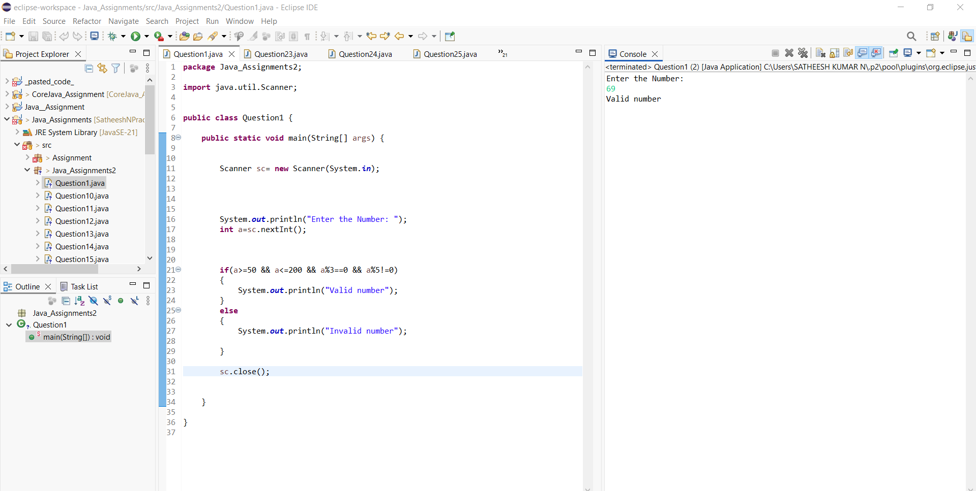

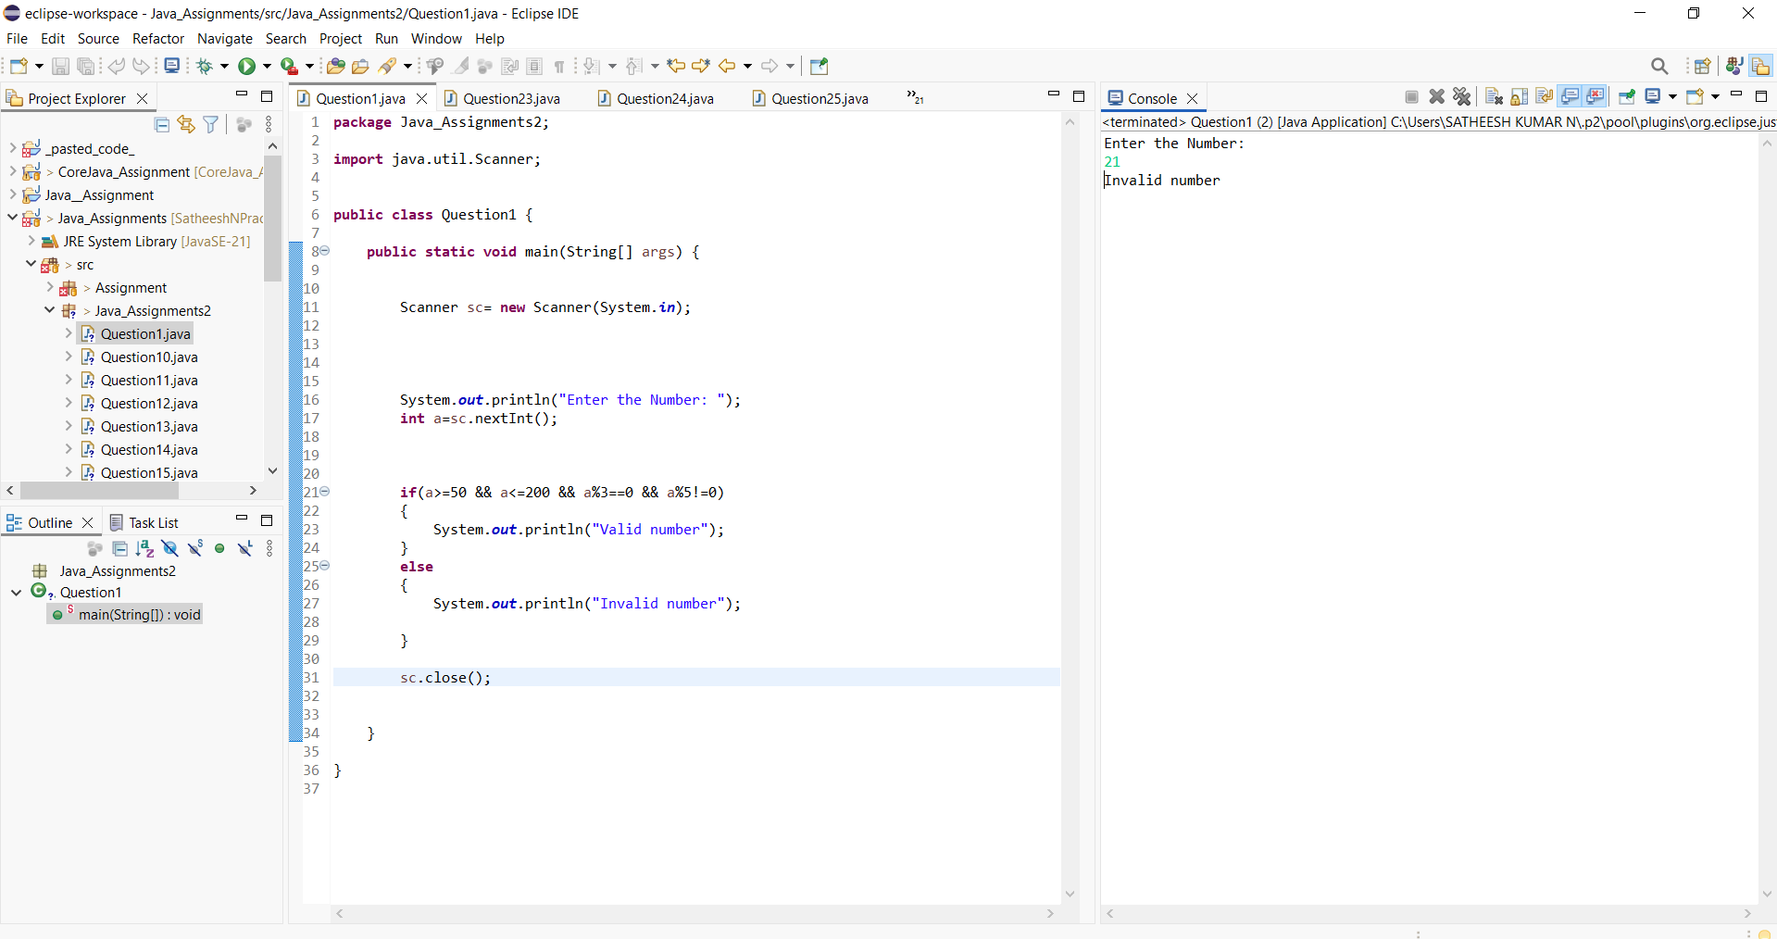

2.Given three integers a, b, and c, print the second largest number using:

Only if–else

***Program and Output:***

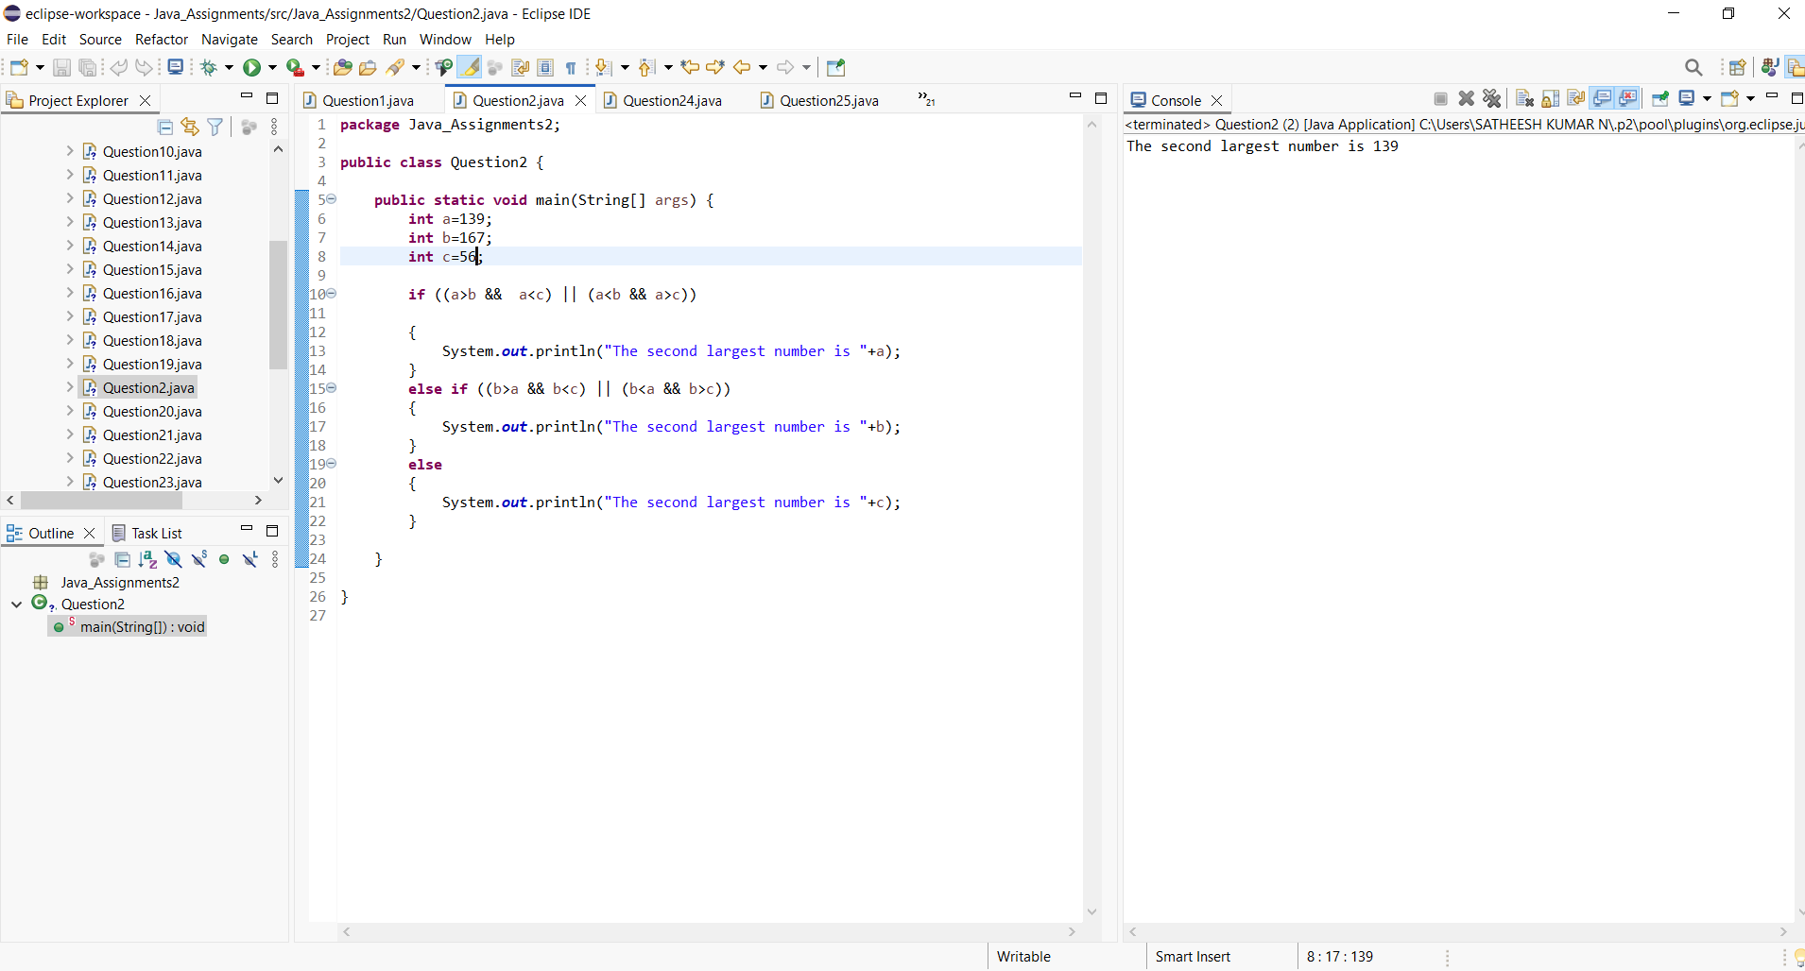

3. Write a program to check if a year is a leap year but:

***Program and output:***

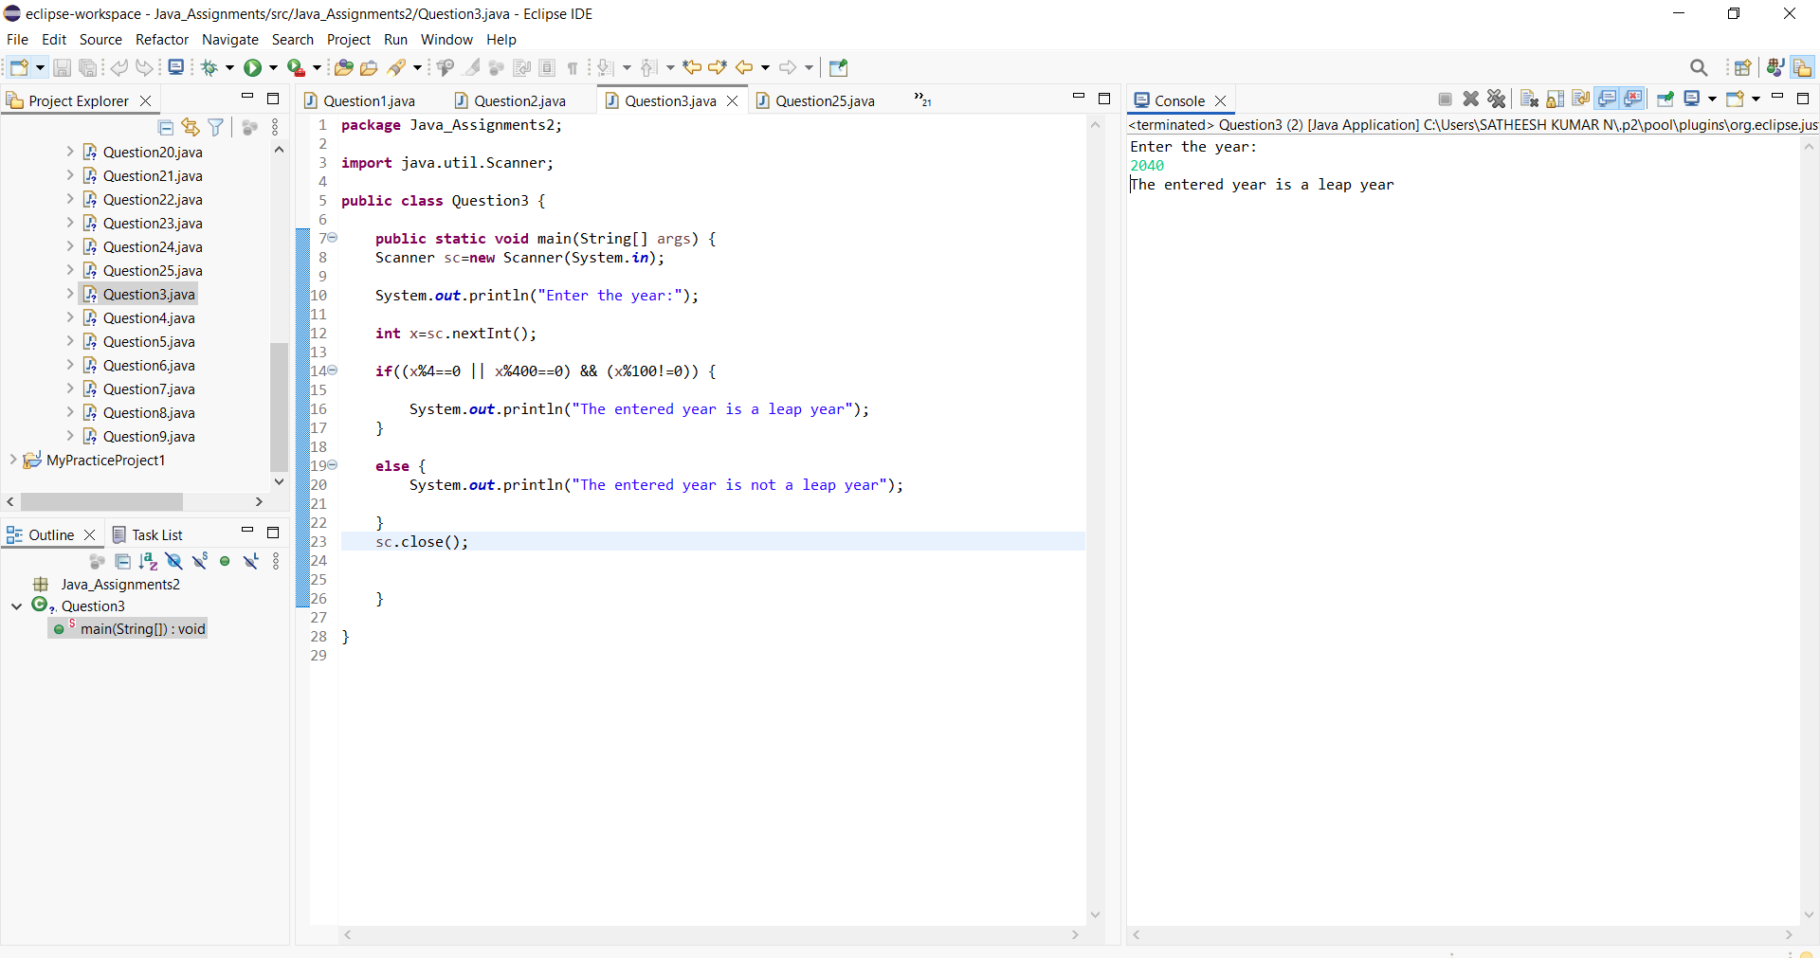

4. Input an integer and determine whether:

It is positive and divisible by 4

OR negative and divisible by 6

***Program and output:***

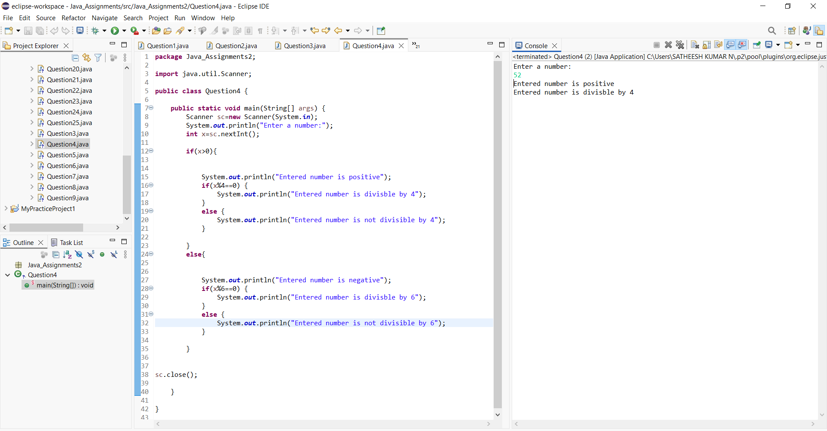

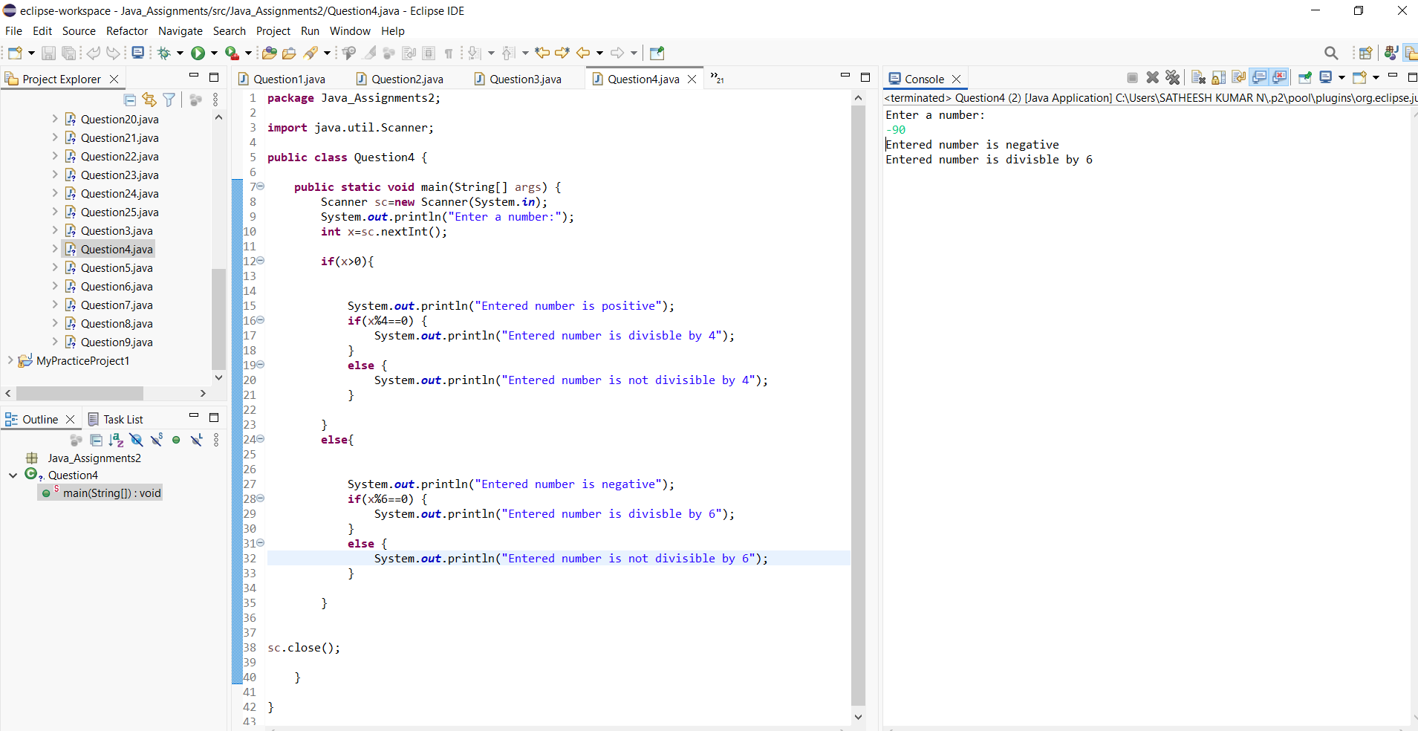

5. Write a program that prints:

"A" if number divisible by 2 and 3

"B" if divisible by 3 and not by 2

"C" if divisible by 2 and not by 3

"D" otherwise

***Program and output:***

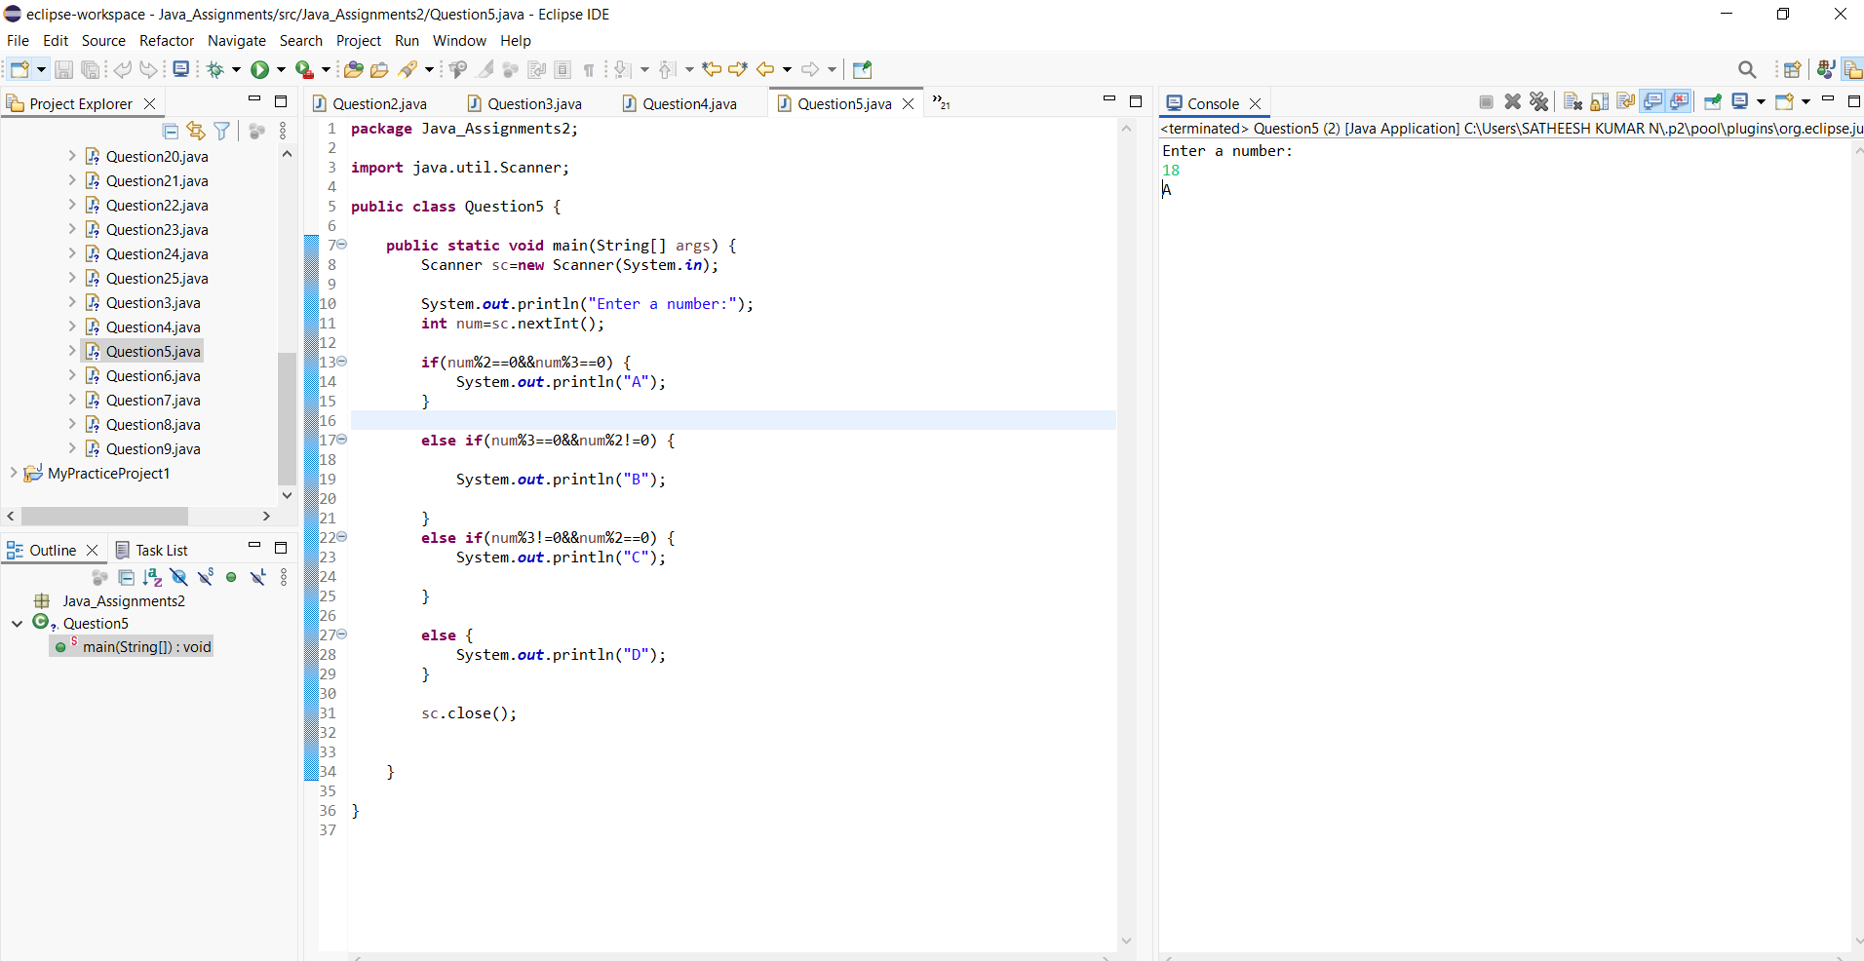

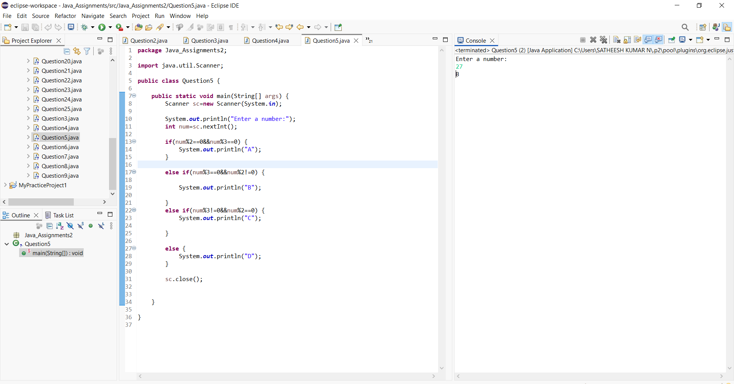

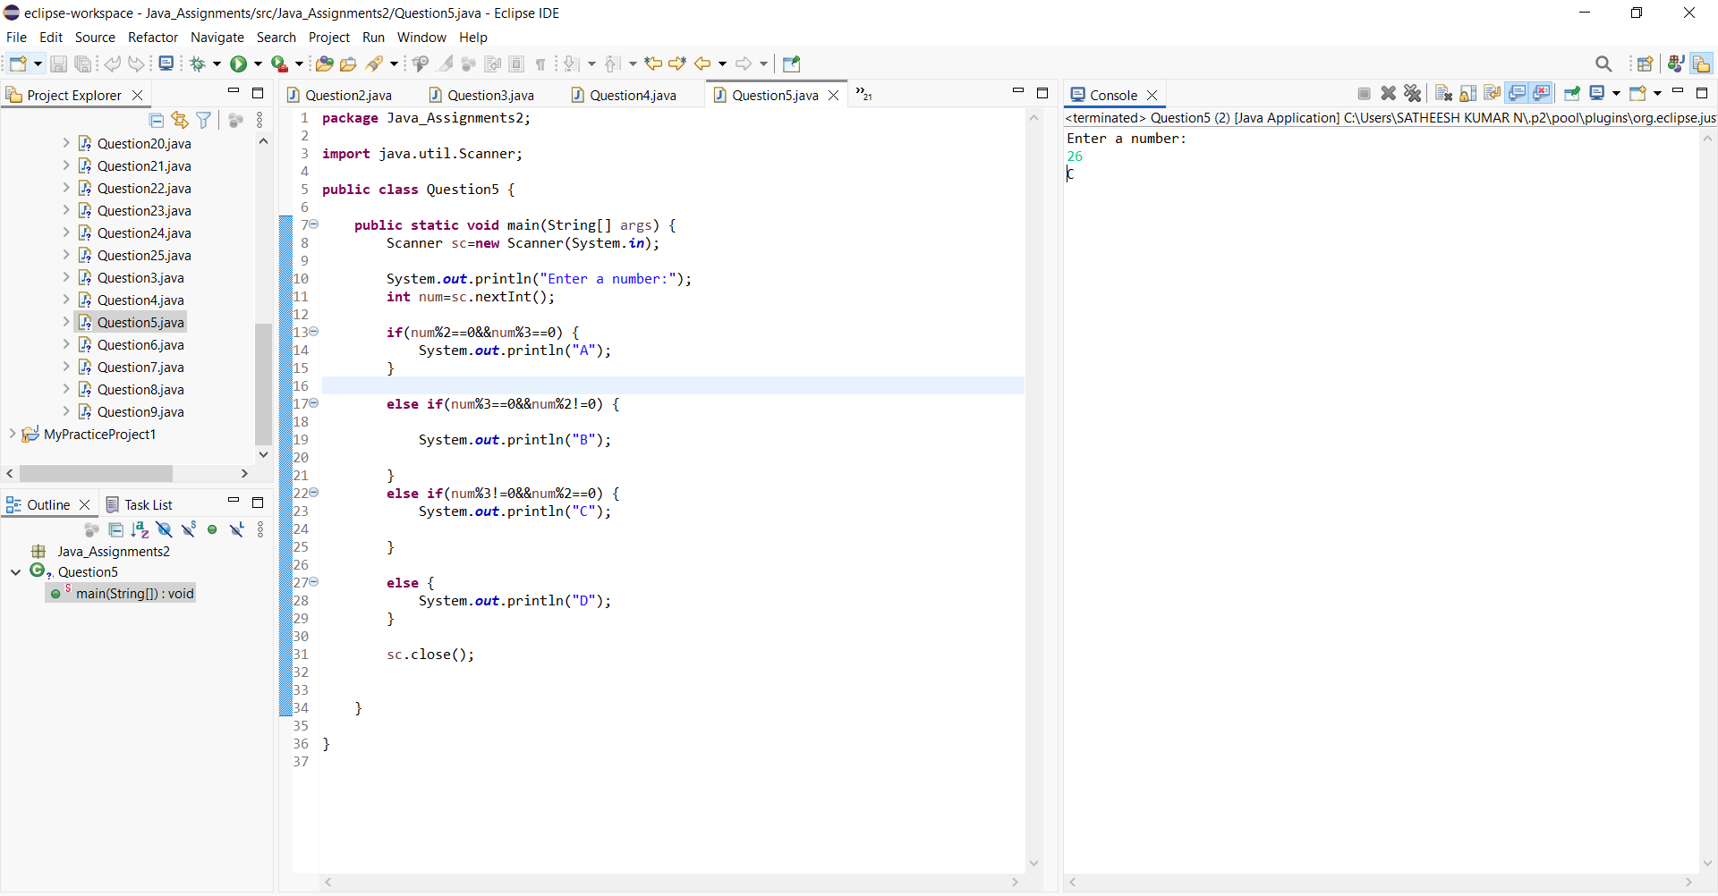

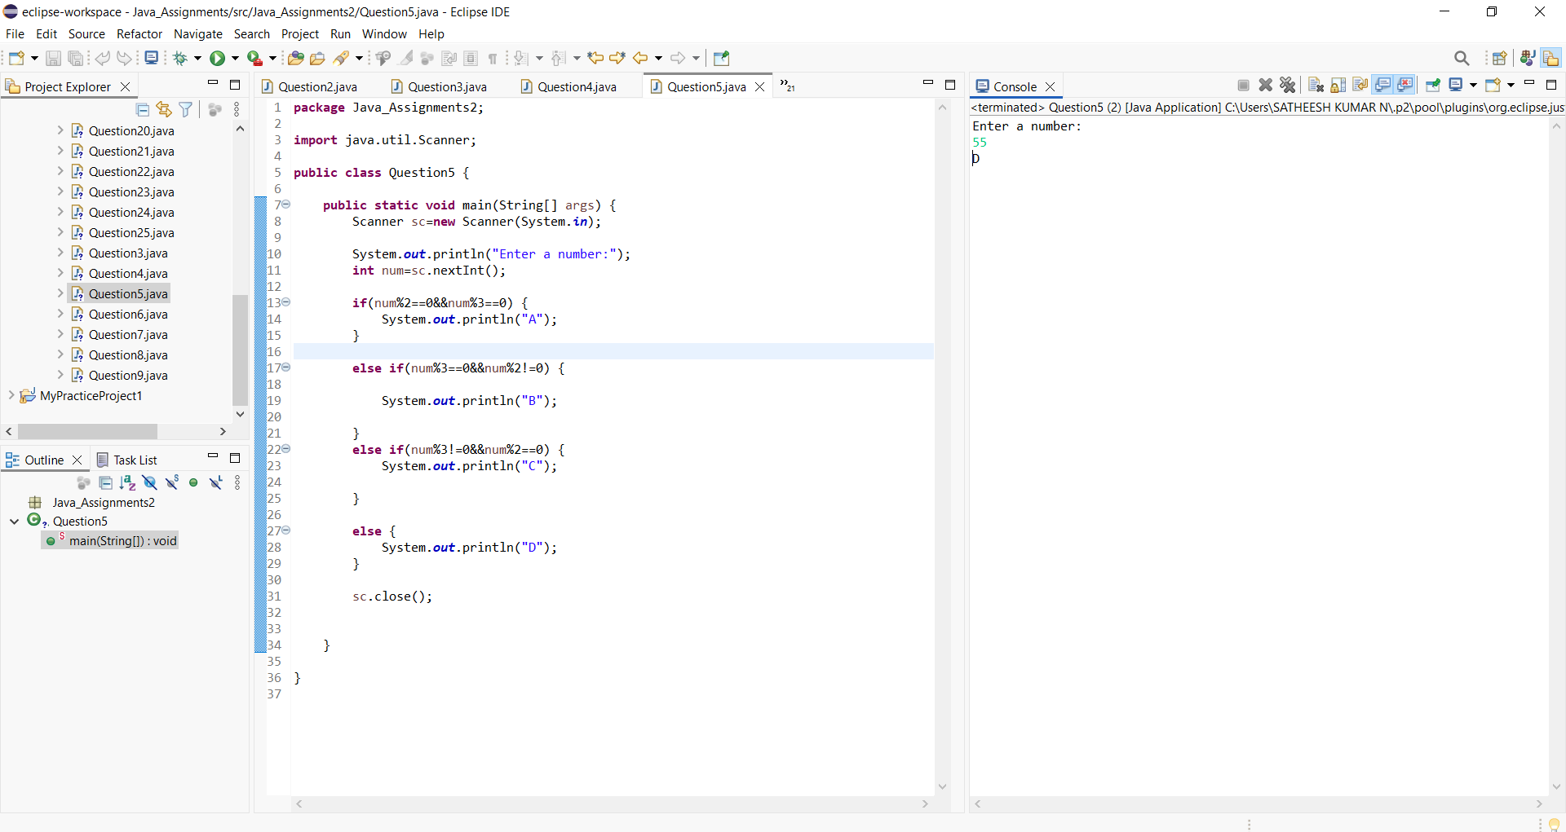

6. Given marks in Math, Physics, Chemistry, determine eligibility:

Math ≥ 60

Physics ≥ 50

Chemistry ≥ 40

AND

Total ≥ 180 OR Math + Physics ≥ 120

***Program and output:***

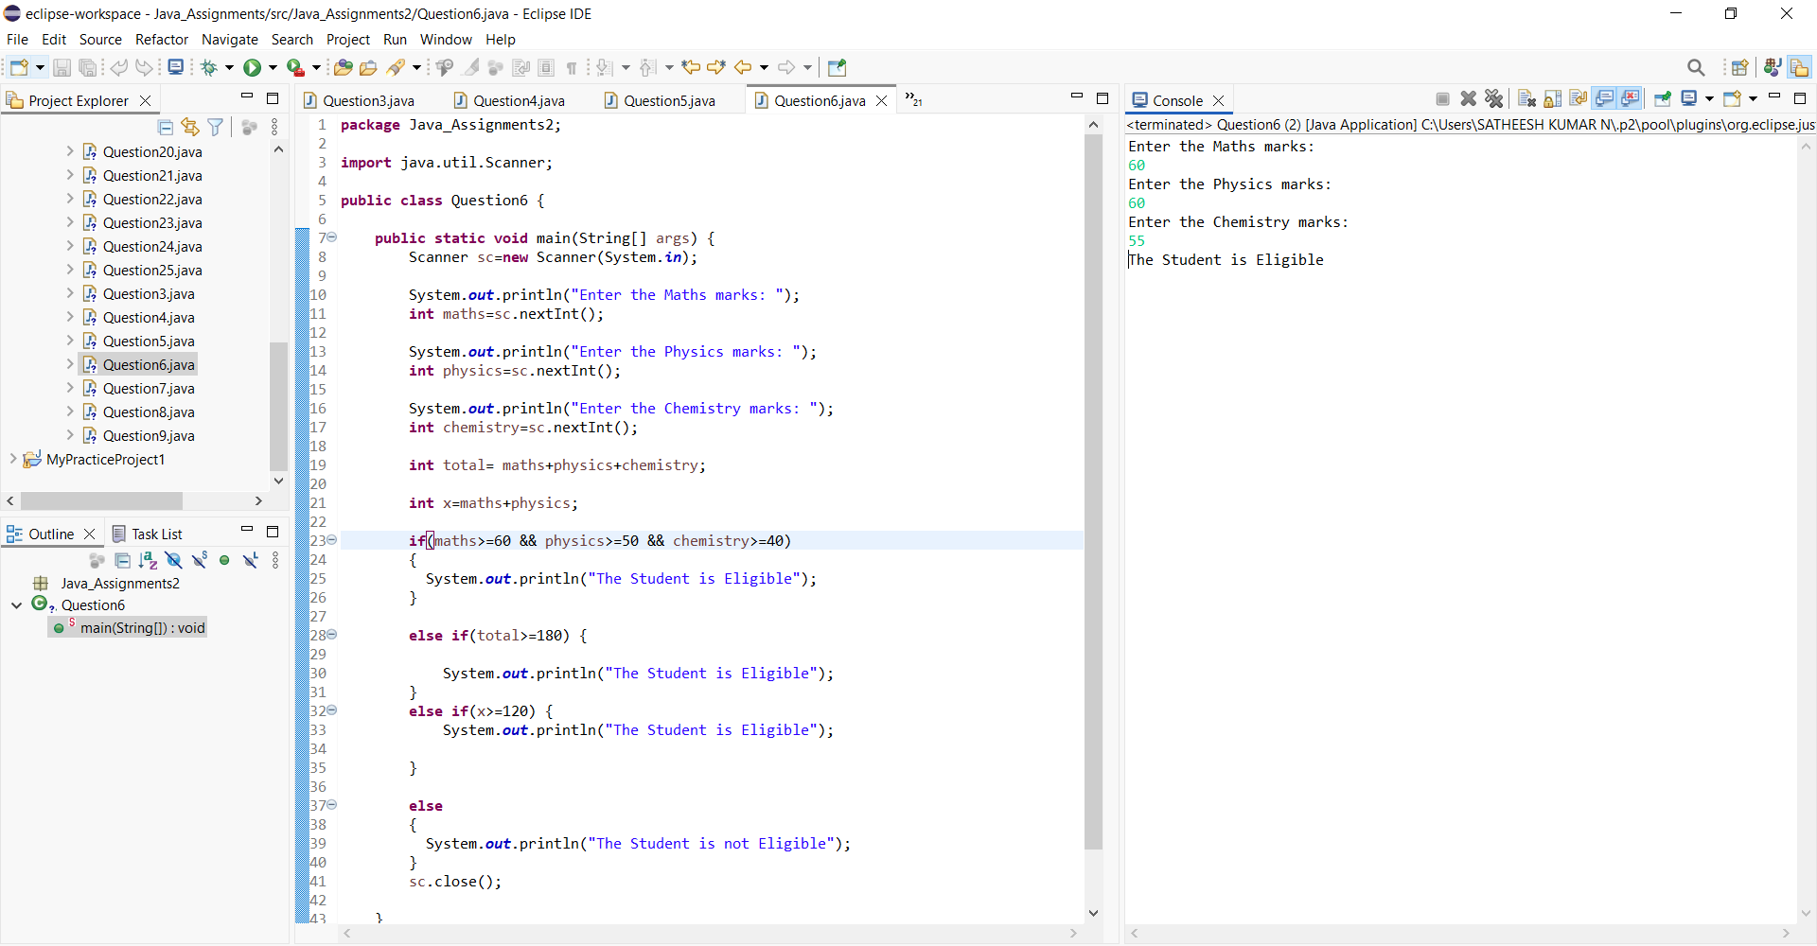

7.Write a program to find the largest of four numbers using:

Nested if–else only

No loops

No arrays

***Program and output:***

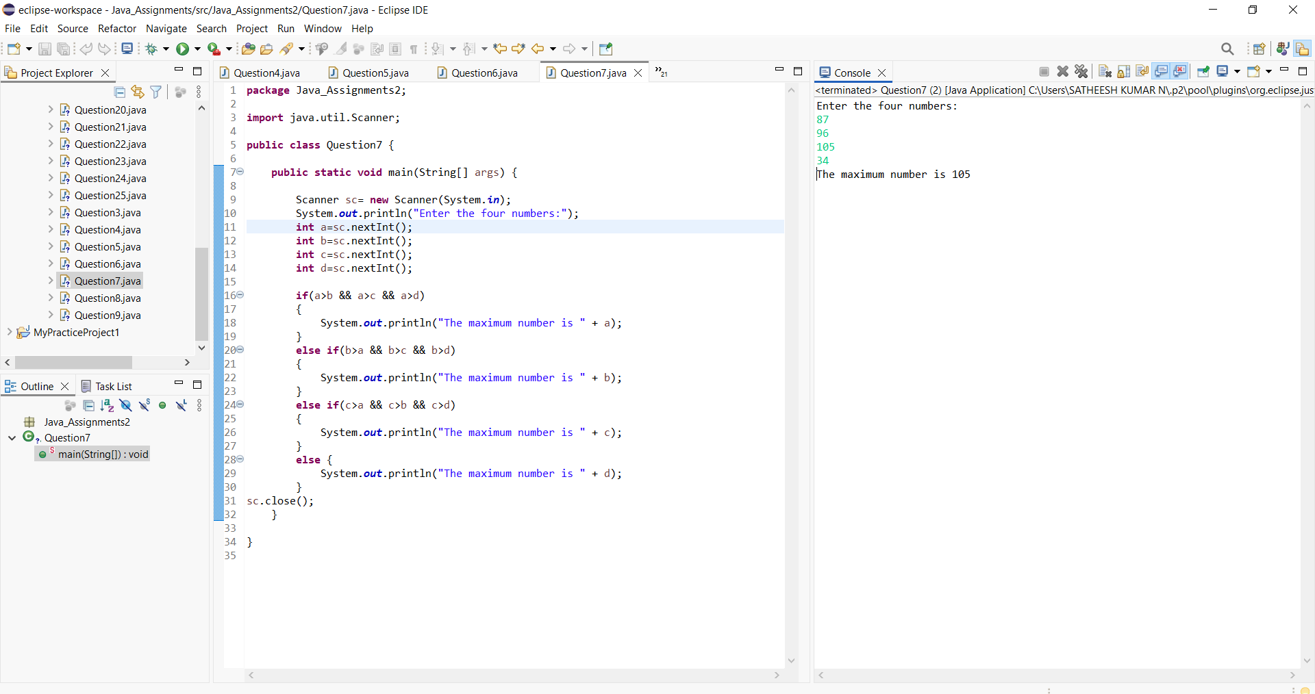

8. Given age and salary:

If age < 25 → Not eligible

If age ≥ 25 and salary < 30000 → Eligible for loan A

If age ≥ 30 and salary ≥ 50000 → Eligible for loan B

➡️ Use deep nested if

***Program and output:***

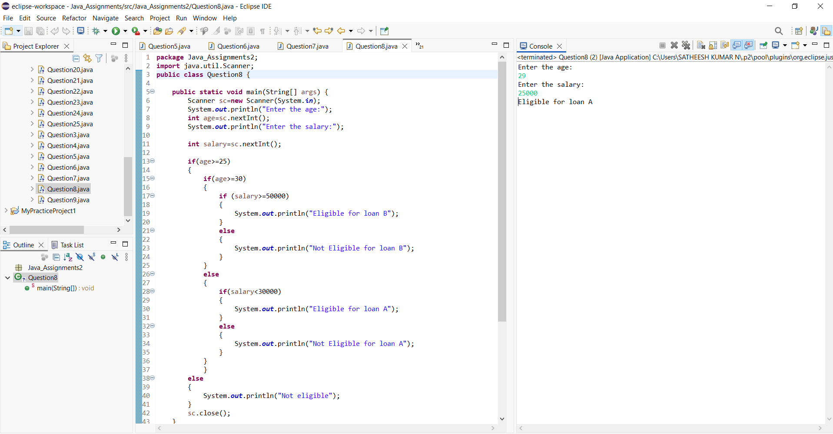

9.Write a program that classifies a character as:

Uppercase vowel

Uppercase consonant

Lowercase vowel

Lowercase consonant

***Program and output:***

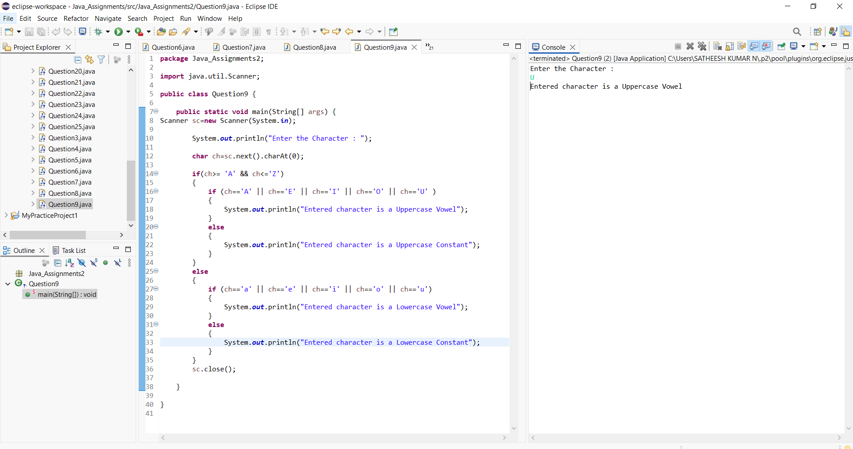

10. Input a number and check:

If it’s a 3-digit number

If yes, check whether the sum of digits is even or odd

➡️ Use nested if only

***Program and output:***

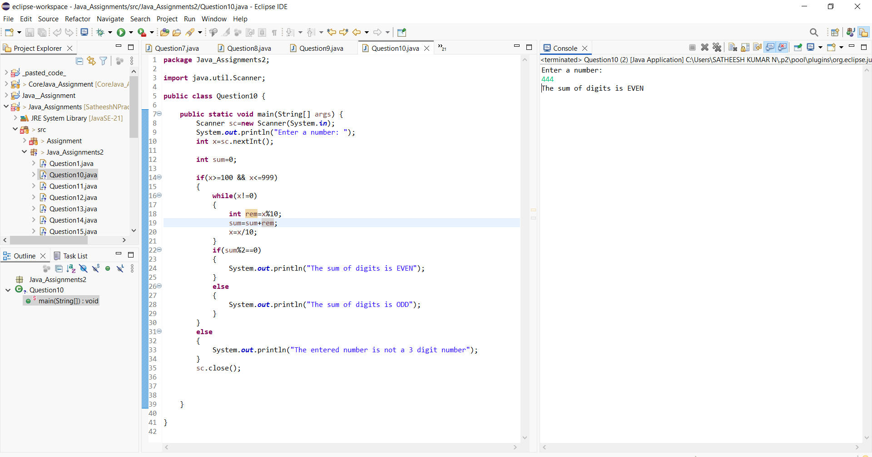

🔹 WHILE LOOP (Tricky Iterations)

11.Print numbers from 1 to 100 but:

Skip numbers divisible by both 3 and 5

Stop completely when number reaches 77

***Program and output:***

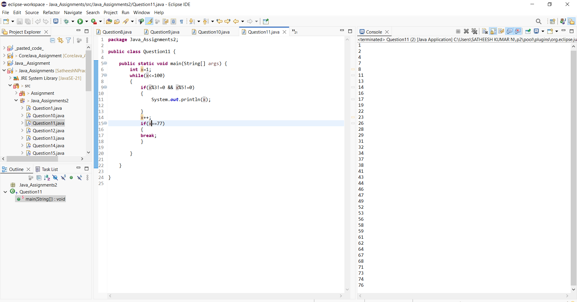

➡️ Use while only

12. Write a program to reverse a number using while, but:

Stop reversing if digit 0 is encountered

***Program and output:***

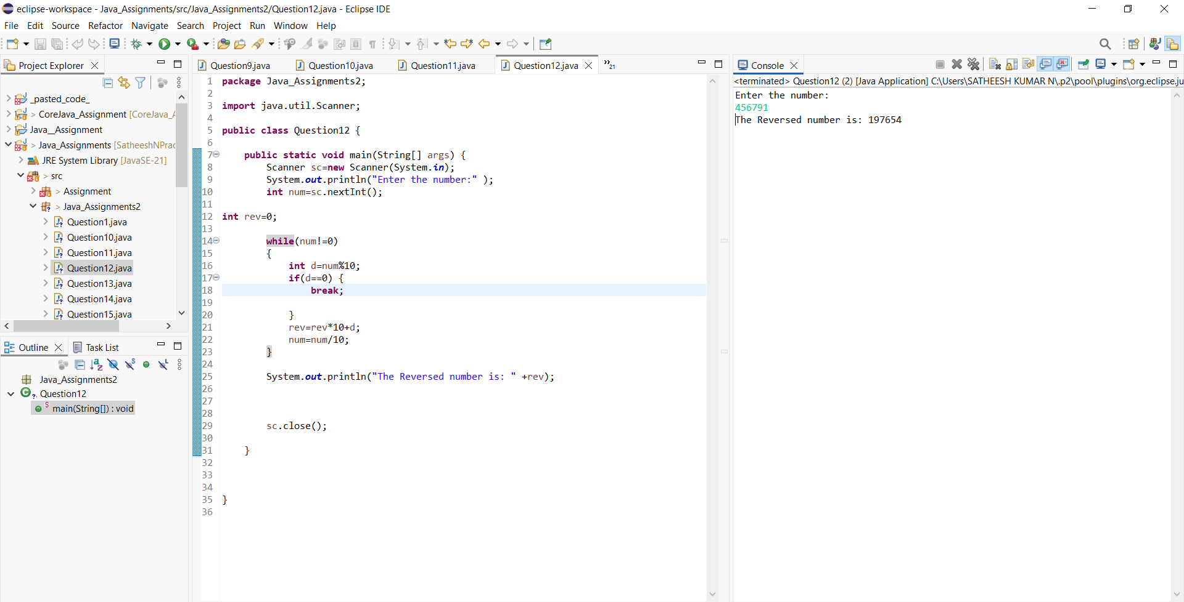

13.Find the count of prime digits in a number using while loop only

**Program and output:**

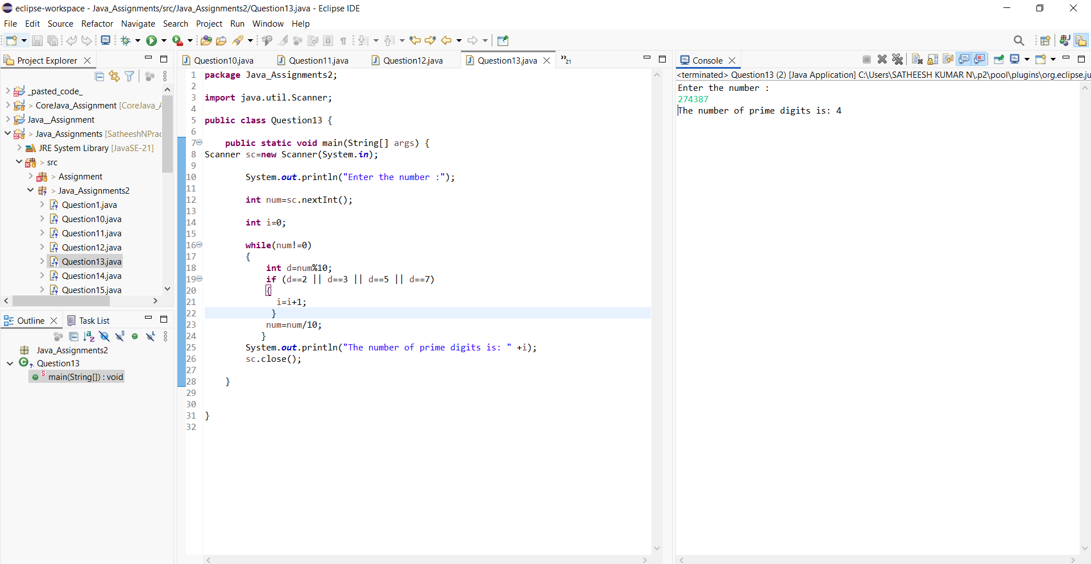

14.Write a program that prints the Fibonacci series up to N terms, but:

Stop printing when a number exceeds 500

***Program and output:***

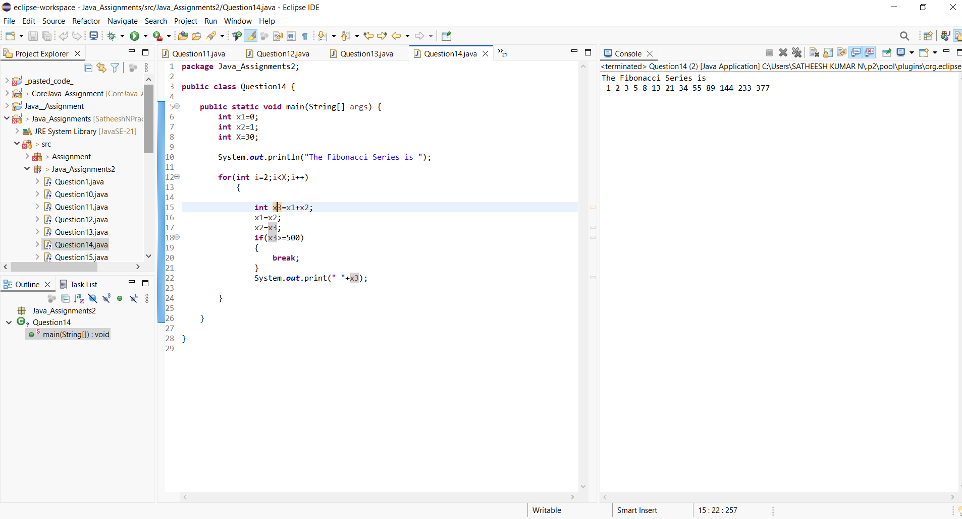

15.Using while, print the following sequence:

1 2 4 7 11 16 22 ...

(up to N terms)

***Program and output:***

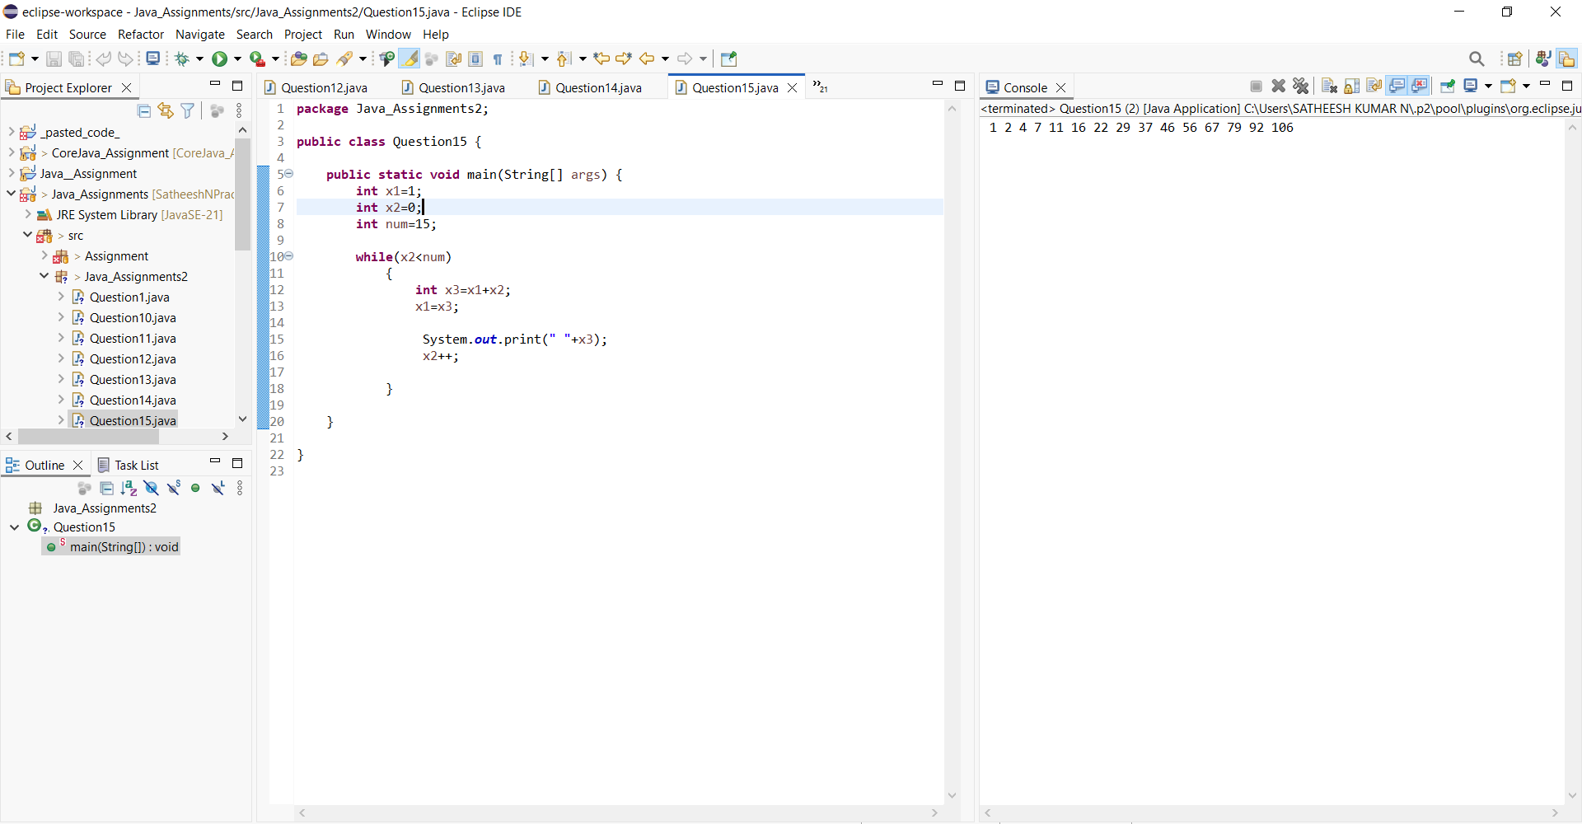

🔹 DO–WHILE LOOP (Edge Cases)

16.Write a program that:

Takes user input until a negative number is entered

Prints sum of all even numbers entered

***Program and output:***

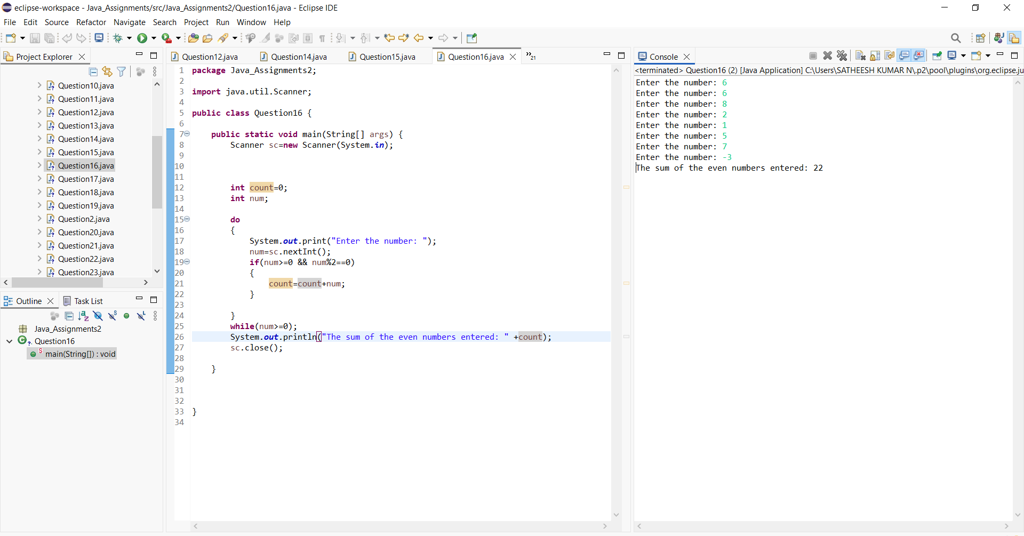

➡️ Use do–while

17. Using do–while, print digits of a number from left to right

(No strings, no arrays)

***Program and output:***

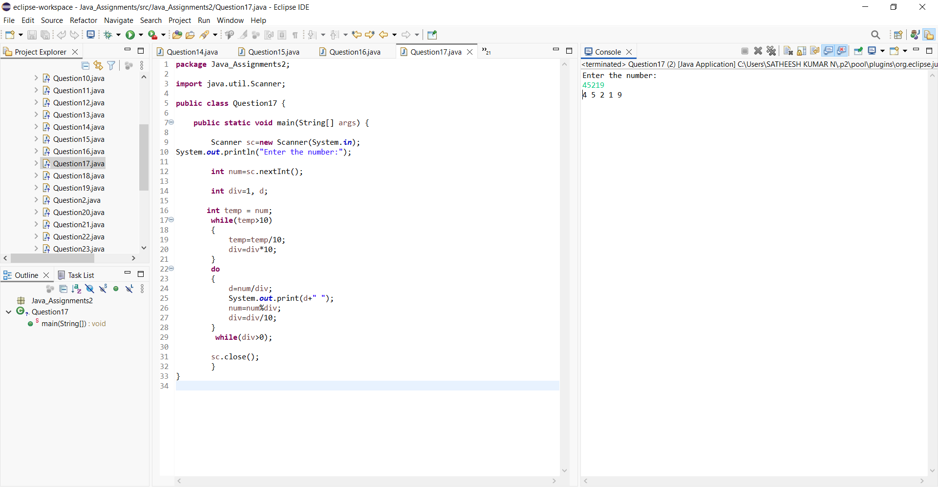

18.Write a program that executes at least once, even if condition is false, and prints:

Loop Executed

***Program and output:***

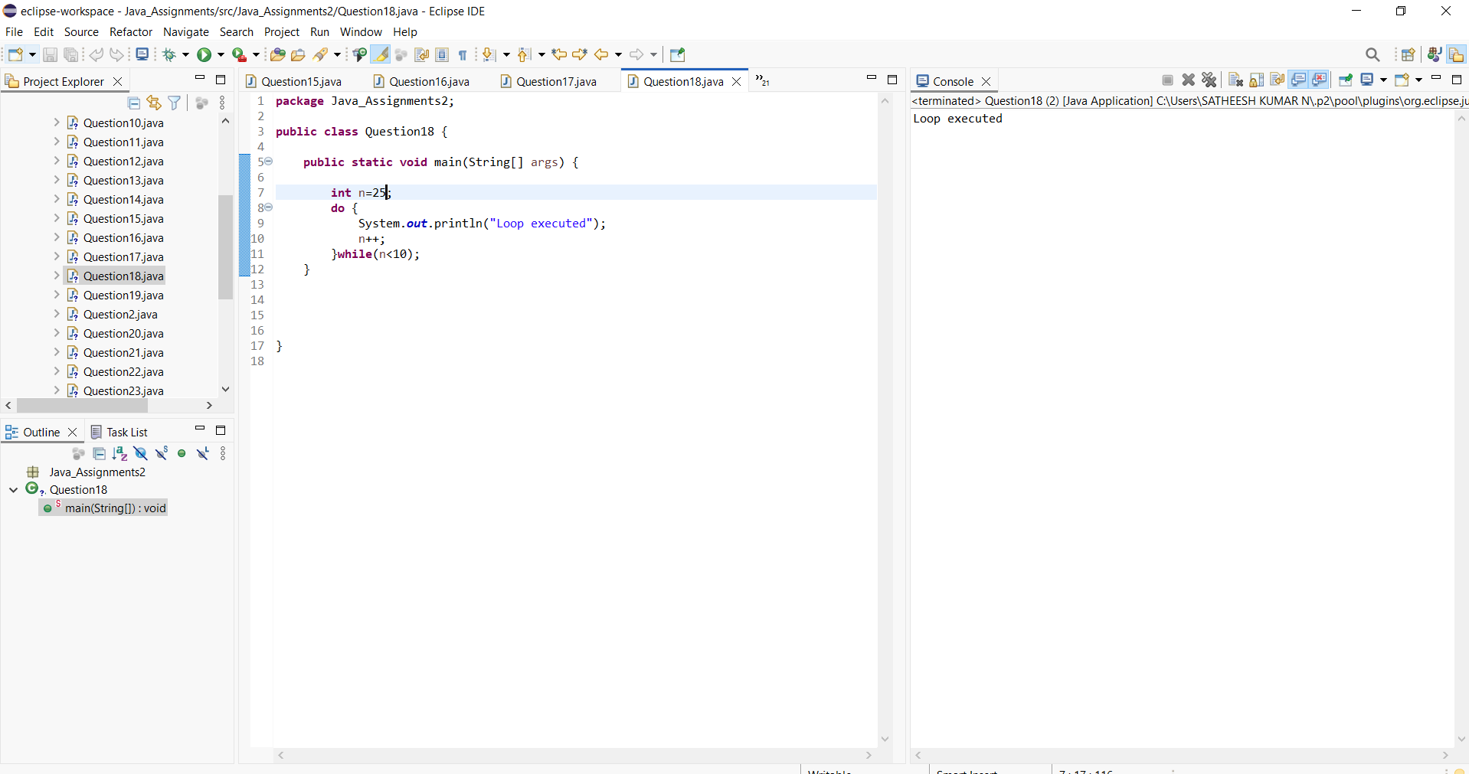

➡️ Modify condition logically

19.Create a menu-driven program using do–while:

Add

Subtract

Multiply

Exit

***Program and output:***

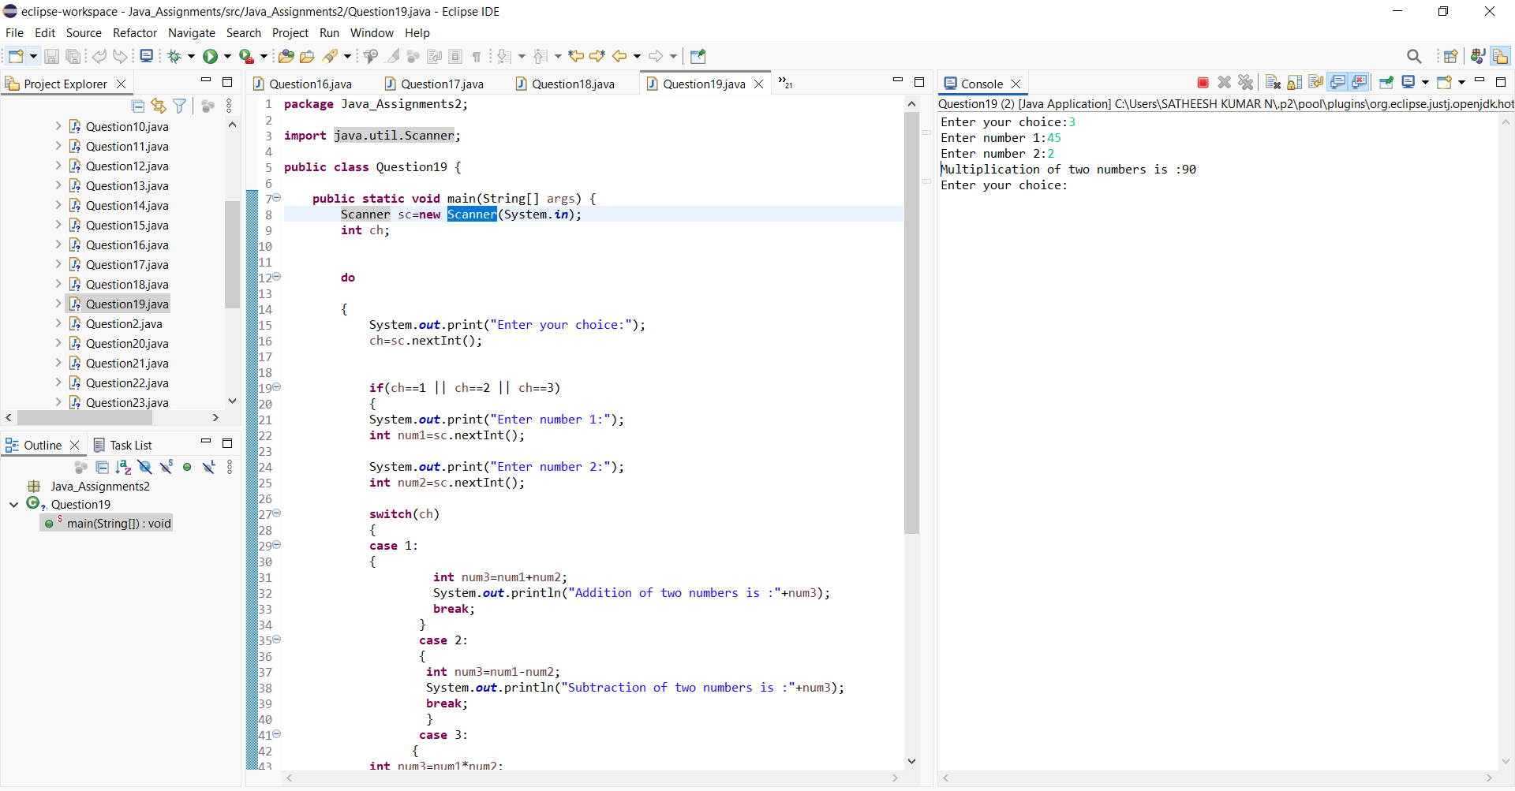

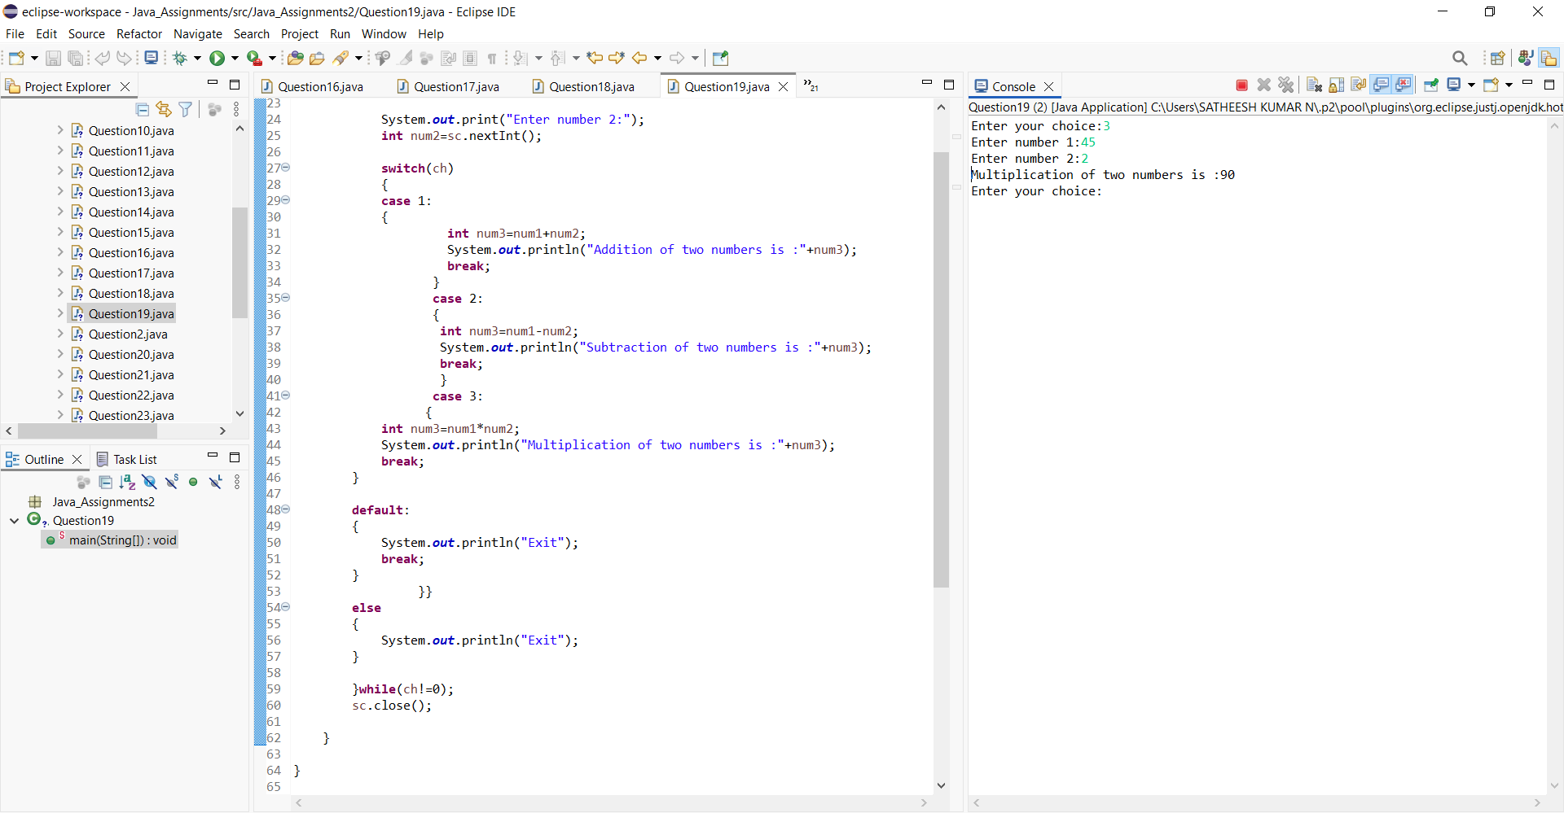

20.Using do–while, find whether a number is palindrome, but:

Exit loop early if mismatch is found

***Program and output:***

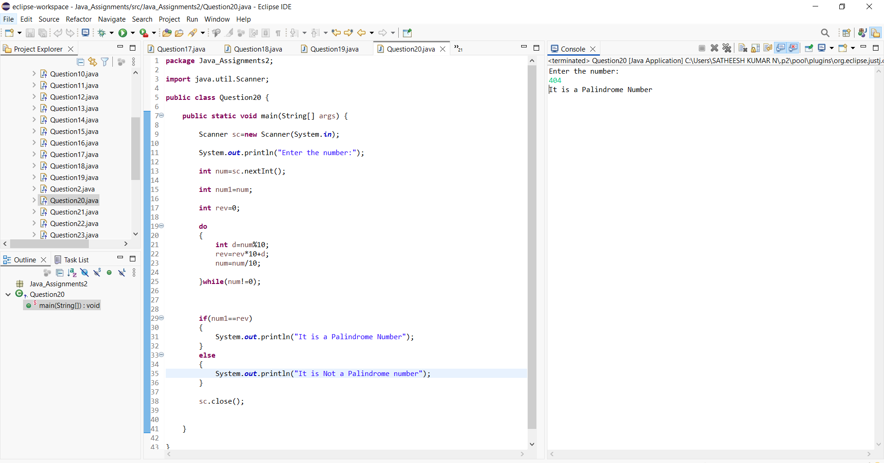

🔹 FOR LOOP (Advanced Logic)

21.Print all numbers between 1 and 500 that:

Have exactly 3 divisors

***Program and output:***

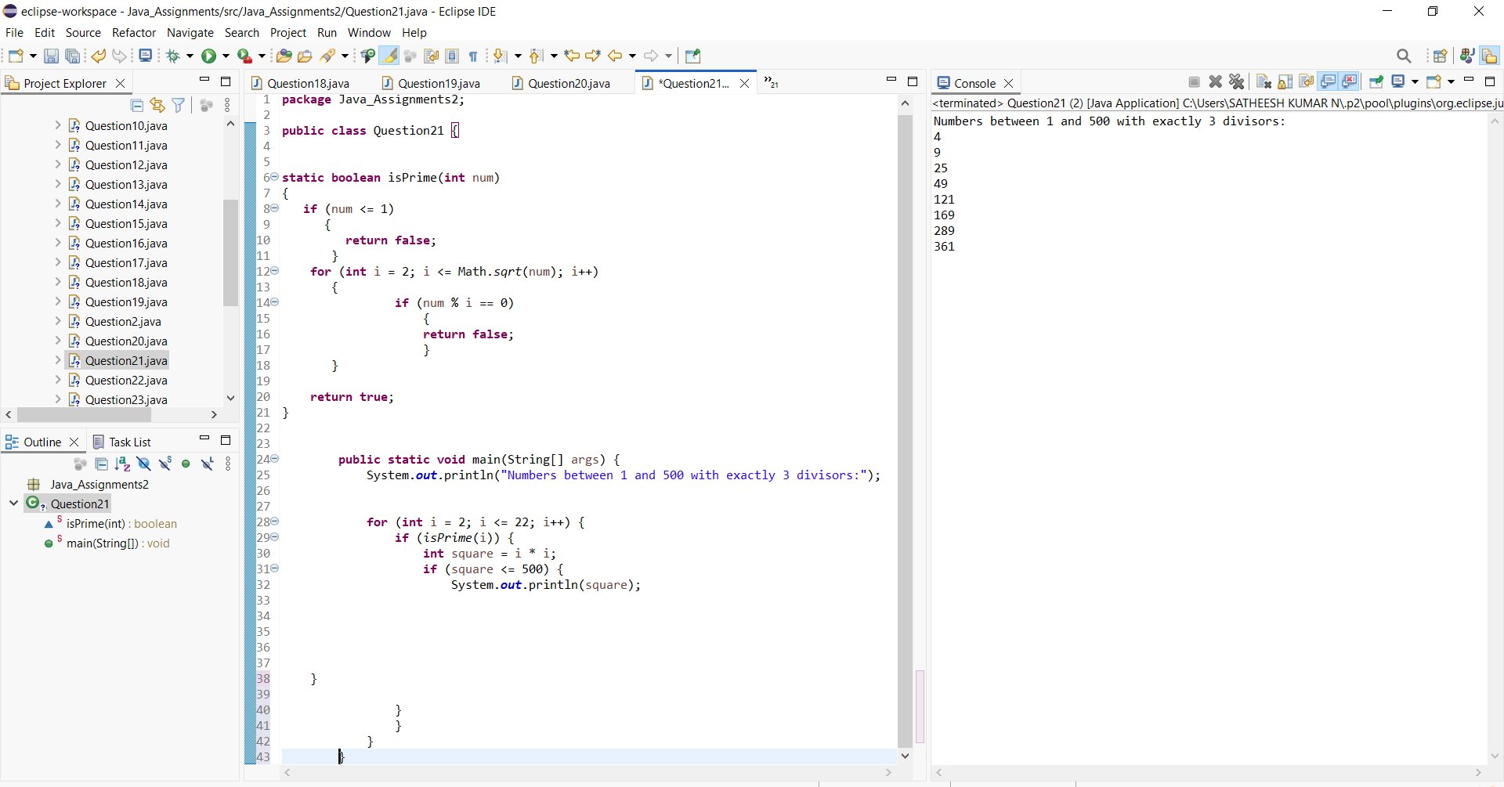

22. Using for, find the largest palindrome number between 100 and 1000

***Program and output:***

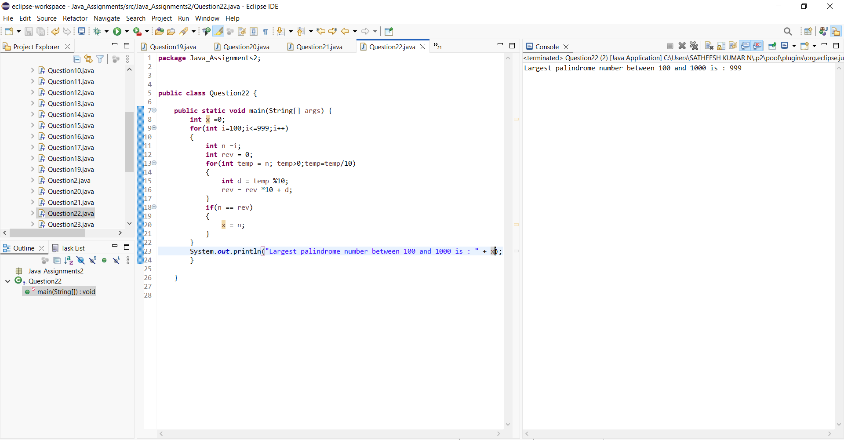

23.Print this pattern using nested for:

1

12

123

1234

12345

But skip printing 3 in all rows

***Program and output:***

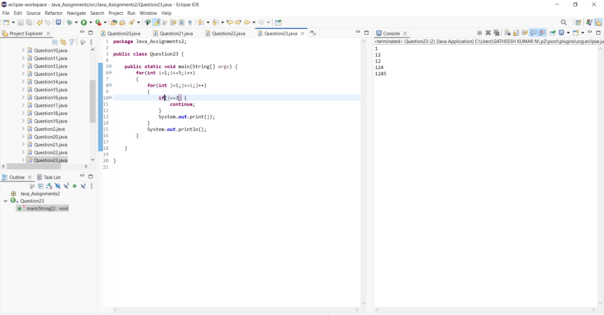

24. Using nested for, print:

5 4 3 2 1

4 3 2 1

3 2 1

2 1

1

But do NOT use subtraction operator (-)

***Program and output:***

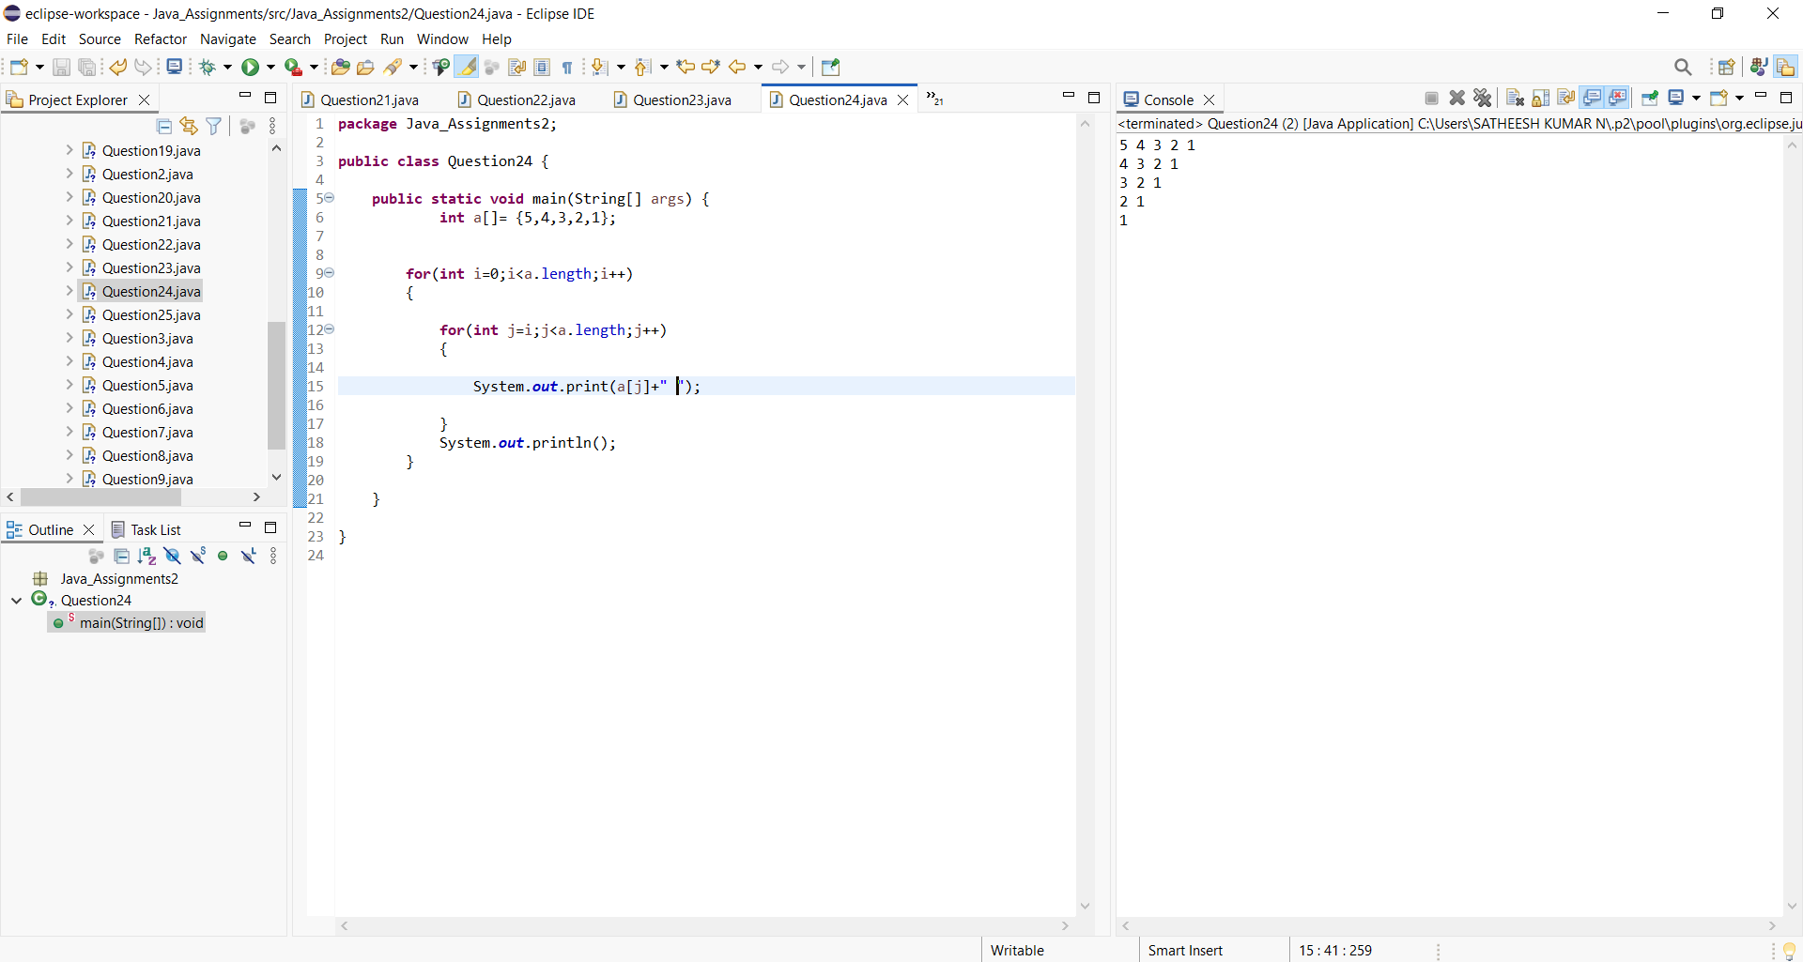

25. Write a program to print all perfect numbers between 1 and 10000 using:

Nested for

if condition only

***Program and output:***

